**Use Case 22: Login**

Brief Description: The user can log into their account with their username and password. A failed login attempt can result in a prompted message from the system regarding the error. A successful login will result in access to personal account details and gained website permissions.

**System Requirements**

*Operational*

1. The system will operate on Windows 7, 8 & 10, Linux 2005 Minimum, or MAC OS 10.0
2. The system will need at least 4 GB of free disk space
3. The system will need internet connection for software activation
4. The system will work on all web browsers
5. The system will integrate with the existing University of Louisville Research database
6. The system will work on mobile devices

*Performance*

1. The system will run 24 hours per day, 365 days per year
2. The system will support the capacity of the University of Louisville’s Research Database
3. The system will handle 100 transactions per hour

*Security*

1. The system allows users to see their transaction history
2. The system encrypts all transactions

*Functional*

1. The system displays the login page to the user when prompted
2. The system searches, validates, and authenticates the submitted credentials

**Trace Matrix**

The system is available to those within the operational requirements. Those with accounts, such as admins, students, researchers, and industry members, will be able to access their personal information and individual permissions will become available to them should they successfully login.

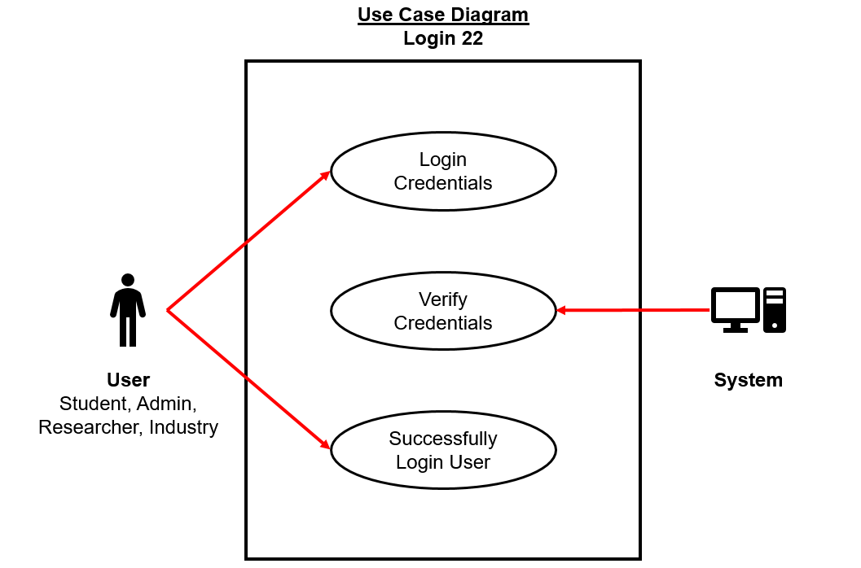**Use Case Diagram**

**Use Case Diagram Narrative**

This use case diagram describes the flow of action through which the actor (student, admin, researcher, or industry) logs into the system. The system verifies the entered credentials and allows the user to log in.

**Prototype**

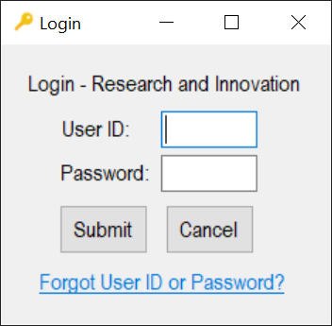

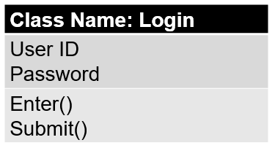**Class Diagram**

**Class Diagram Narrative**

The login class diagram contains User ID and Password attributes. The User class contains two methods, enter and submit. It interacts with the User Data class to login, and the User Data class interacts with the Roles class to distribute permissions.

**Sequence Diagram**

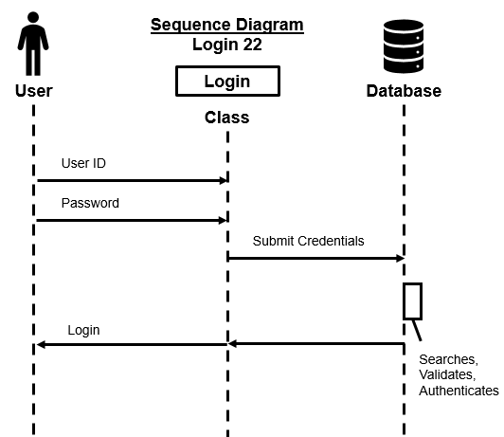

Main Flow

* User enters username
* User enters password
* User submits login

**Sequence Diagram Narrative**

The User enters their User ID and Password. The Login form submits the credentials to the database which searches, validates, and authenticates them. If the credentials are correct, the user can login.

**Use Case 22: Backup Data**

Brief Description: The admin can log into their account and a create a copy of computer data. They can store it elsewhere so that in the case of a data loss, they will retain their information.

**System Requirements**

*Operational*

1. The system will operate on Windows 7, 8 & 10, Linux 2005 Minimum, or MAC OS 10.0
2. The system will need a 2.8 GHz or faster processor
3. The system will need at least 4 GB of free disk space
4. The system will need internet connection for software activation
5. The system will integrate with the existing University of Louisville Research database

*Performance*

1. Any interaction between user and system should not exceed 1 second
2. The system will update every 30 minutes
3. The system will run 24 hours per day, 365 days per year
4. The system will support the capacity of the University of Louisville’s Research Database
5. The system will handle 100 transactions per hour

*Security*

1. The system will allow users to see their transaction history
2. The system will allow only the administrator to see staff personal records
3. The system will encrypt all transactions

*Cultural & Political*

1. The system will comply with privacy standards

*Functional*

1. The system will allow system backups

**Trace Matrix**

The system is available to those within the operational requirements. Those with an admin account will be able to activate a data backup and their permissions will become available to them should they successfully login. Only admins will be able to see personal data, such as staff records, maintaining privacy standards.

**Use Case Diagram**

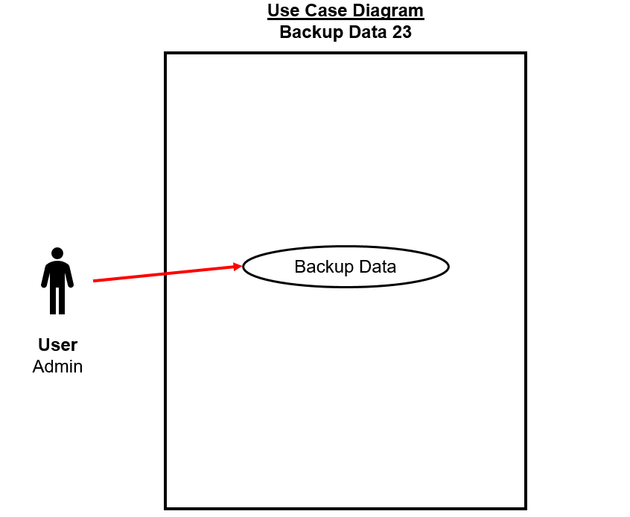

**Use Case Diagram Narrative**

This use case diagram describes the flow of action through which the actor (admin) logs into the system and starts a data backup. The system verifies their permissions and allows them access to this functionality.

**Prototype**

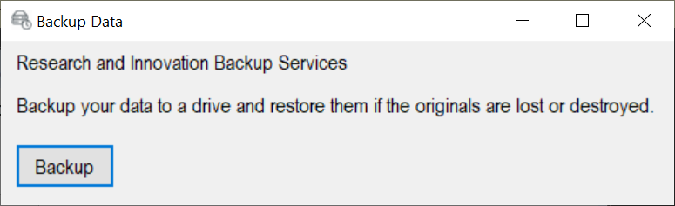

**Class Diagram**

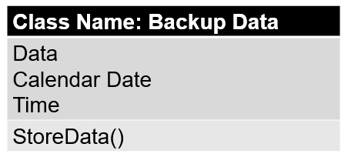

**Class Diagram Narrative**

The backup data class diagram contains Data, Calendar Date, and Time attributes. The class contains one method, store data. It interacts with the restore data class because the data must be accessed for a rebuild.

**Sequence Diagram**

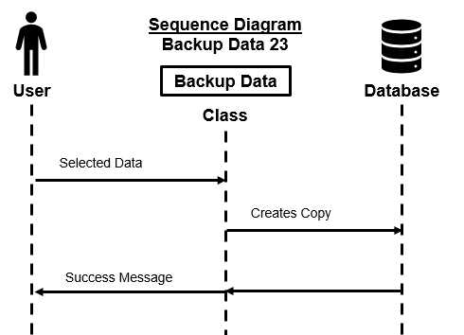

Main Flow

* System backs up the data that has been entered

**Sequence Diagram Narrative**

The User selects what data they would like to backup, whether that be individual pieces or everything. The form prompts the user to begin a backup and later narrows down what the user wants to save. The system makes a copy which is stored on a drive or within the database. When completed, the user will receive a success message with the location of the information.

**Use Case 23: Restore Data**

Brief Description: The admin can log into their account and restore and rebuild the website in the case of data loss due to a previous copy being made.

**System Requirements**

*Operational*

1. The system will operate on Windows 7, 8 & 10, Linux 2005 Minimum, or MAC OS 10.0
2. The system will need a 2.8 GHz or faster processor
3. The system will need at least 4 GB of free disk space
4. The system will need internet connection for software activation
5. The system will integrate with the existing University of Louisville Research database

*Performance*

1. Any interaction between user and system should not exceed 1 second
2. The system will update every 30 minutes
3. The system will run 24 hours per day, 365 days per year
4. The system will support the capacity of the University of Louisville’s Research Database
5. The system will handle 100 transactions per hour

*Security*

1. The system will allow users to see their transaction history
2. The system will allow only the administrator to see staff personal records
3. The system will encrypt all transactions

*Cultural & Political*

1. The system will comply with privacy standards

*Functional*

1. The system will allow system restores

**Trace Matrix**

The system is available to those within the operational requirements. Those with an admin account will be able to activate a data restore and their permissions will become available to them should they successfully login. Only admins will be able to see personal data, such as staff records, maintaining privacy standards.

**Use Case Diagram**

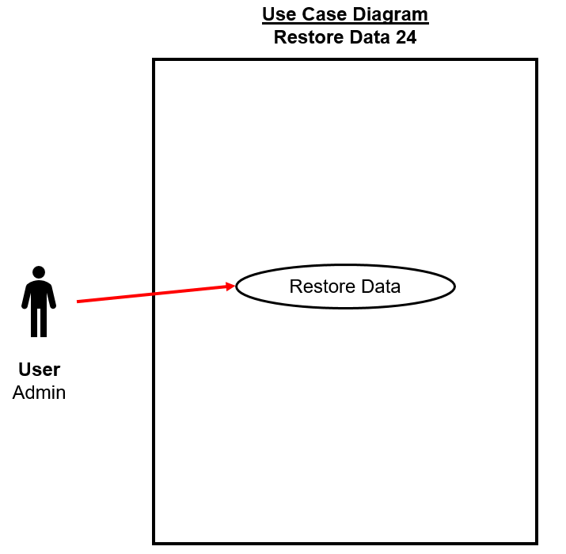

**Use Case Diagram Narrative**

This use case diagram describes the flow of action through which the actor (admin) logs into the system and starts a data backup. The system verifies their permissions and allows them access to this functionality.

**Prototype**

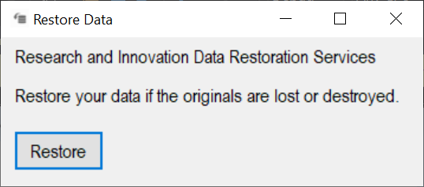

**Class Diagram**

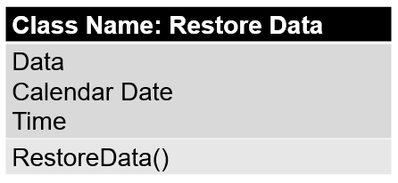

**Class Diagram Narrative**

The backup data class diagram contains Data, Calendar Date, and Time attributes. The class contains one method, restore data. It interacts with the backup data class because the data must be accessed for a rebuild.

**Sequence Diagram**

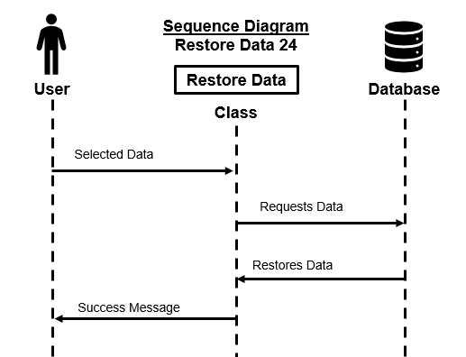

Main Flow

* System recovers previously backed up data

**Sequence Diagram Narrative**

The User selects what data version they would like to restore. The form prompts the user to begin a restore. The system finds the copy which is stored on a drive or within the database. When completed, the user will receive a success message.

**Use Case 29: Link the Donation Process Directly to UofL Development Departments**

Brief Description: The admin can add links to other university departments and resources, in this case, the development department for donations.

**System Requirements**

*Operational*

1. The system will operate on Windows 7, 8 & 10, Linux 2005 Minimum, or MAC OS 10.0
2. The system will need a 2.8 GHz or faster processor
3. The system will need at least 4 GB of free disk space
4. The system will need internet connection for software activation
5. The system will integrate with the existing University of Louisville Research database

*Performance*

1. Any interaction between user and system should not exceed 1 second
2. The system will update every 30 minutes
3. The system will run 24 hours per day, 365 days per year
4. The system will support the capacity of the University of Louisville’s Research Database
5. The system will handle 100 transactions per hour

*Security*

1. The system will allow users to see their transaction history
2. The system will allow only the administrator to see staff personal records
3. The system will encrypt all transactions

*Cultural & Political*

1. The system will comply with privacy standards

*Functional*

1. The system will allow redirects

**Trace Matrix**

The system is available to those within the operational requirements. Those with an admin account will be able to add redirect links to the website and their permissions will become available to them should they successfully login.

**Use Case Diagram**

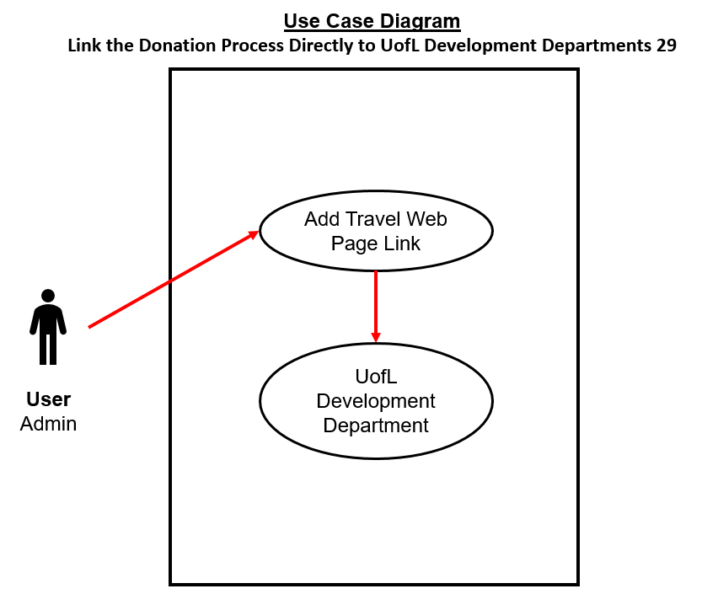

**Use Case Diagram Narrative**

This use case diagram describes the flow of action through which the actor (admin) logs into the system and adds a link redirect. The system verifies their permissions and allows them access to this functionality.

**Prototype**

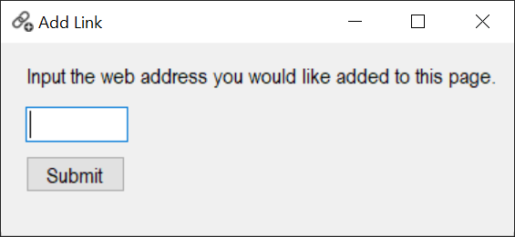

**Class Diagram**

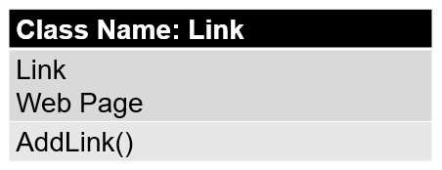

**Class Diagram Narrative**

The link class diagram contains Link and Web Page attributes. The class contains one method, add link.

**Sequence Diagram**

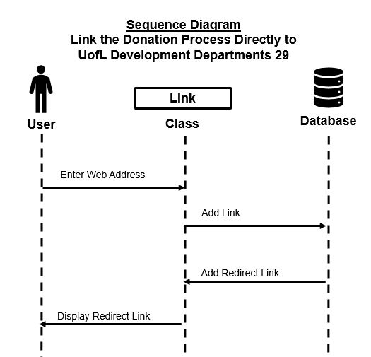

Main Flow

* Industry logs in to the Research and Innovation website
* Industry goes to “For Industry” page
* Industry clicks on “Donation” button
* Industry be directed to UofL development departments’ webpages to continue their donation process

**Sequence Diagram Narrative**

The User types in what link they would like to add to the web page. The form accepts the entry. The system adds the redirect link and it is displayed on the page.

**Use Case 29: Link ThinkIR to the Research Page**

Brief Description: The admin can add links to other university departments and resources, in this case, the ThinkIR research pages.

**System Requirements**

*Operational*

1. The system will operate on Windows 7, 8 & 10, Linux 2005 Minimum, or MAC OS 10.0
2. The system will need a 2.8 GHz or faster processor
3. The system will need at least 4 GB of free disk space
4. The system will need internet connection for software activation
5. The system will integrate with the existing University of Louisville Research database

*Performance*

1. Any interaction between user and system should not exceed 1 second
2. The system will update every 30 minutes
3. The system will run 24 hours per day, 365 days per year
4. The system will support the capacity of the University of Louisville’s Research Database
5. The system will handle 100 transactions per hour

*Security*

1. The system will allow users to see their transaction history
2. The system will allow only the administrator to see staff personal records
3. The system will encrypt all transactions

*Cultural & Political*

1. The system will comply with privacy standards

*Functional*

1. The system will allow redirects

**Trace Matrix**

The system is available to those within the operational requirements. Those with an admin account will be able to add redirect links to the website and their permissions will become available to them should they successfully login.

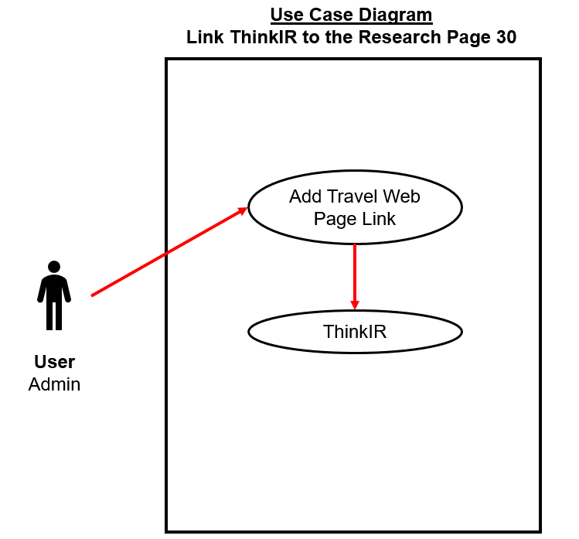**Use Case Diagram**

**Use Case Diagram Narrative**

This use case diagram describes the flow of action through which the actor (admin) logs into the system and adds a link redirect. The system verifies their permissions and allows them access to this functionality.

**Prototype**



**Class Diagram**



**Class Diagram Narrative**

The link class diagram contains Link and Web Page attributes. The class contains one method, add link.

**Sequence Diagram**

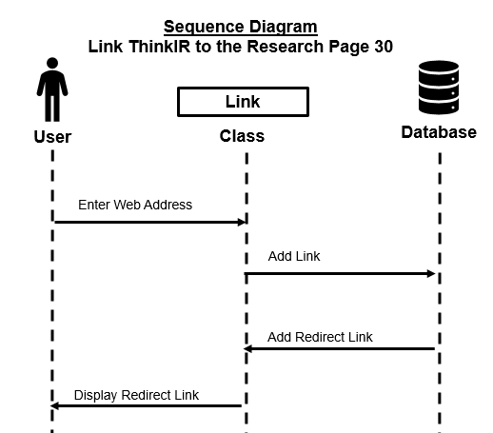

Main Flow

* Industry logs in to the Research and Innovation website
* Industry goes to “For Industry” page
* Industry clicks on “ThinkIR” button
* Industry will be directed to UofL ThinkIR to view what UofL has accomplished

**Sequence Diagram Narrative**

The User types in what link they would like to add to the web page. The form accepts the entry. The system adds the redirect link and it is displayed on the page.